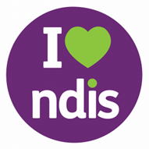
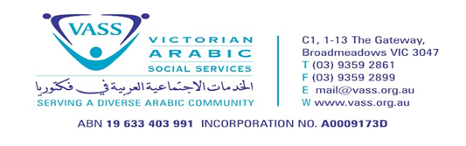
VASS NDIS Referral Form Provider No. 4050023580
(For those already approved for services, wishing to use VASS as a provider)
Date: ___/___/_____
Client details
Name: _______________________________________________________________________________
Address: _____________________________________________________________________________
Phone: ______________________ Email: ________________________________________
Date of birth: ___/___/_____
Preferred language: _____________________ Interpreter needed: Yes No
Gender: Female Male Other/ prefer not to say
Diagnois/ses: __________________________________________________________________________
Management type:
Self-Managed
Plan Managed (if yes, please list): _________________________________________
NDIA Managed
Services requested (please tick all that apply):
Group/ Centre based participation (Social Group)
Participate Community
Assistance with Personal Activities
Household Tasks
Support Coordination
Reason for referral: _____________________________________________________________________________________
Please see next page
Referrer details (if different to above):
Name: ________________________________________
Agency/ organisation name: _____________________________________________________________
Phone: __________________________ Email: ________________________________________
Do you have the client’s consent to make this referral: Yes No
For further information in Arabic please call Farah Abdyashoa 0451 964 549, in Persian Maliheh Saeedi 0432 516 777, in Chaldean/Assyrian 0404 760 203, Turkish 0431 521 789.
Please return filled form to mail@vass.org.au or Maliheh.saeedi@vass.org.au

